Grade 7 Accelerated · Unit 3 · Lesson 2  Quotient Laws of Exponents  Question Bank 3.02 ANSWER KEY | Name  Date  Period

Show your work. Circle your final answer.
For questions 1 through 3, show the quotient of powers law, then evaluate.
1. 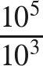


2. 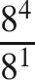


3. 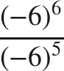
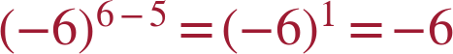
One negative factor left.

4. When dividing two powers that have the same nonzero base, keep the base and ______ the exponents.
subtract
A cloze blank: the word is the answer.

For questions 5 and 6, apply the power of a quotient law. Do not simplify the fraction.
5. 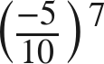
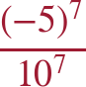
Equivalent to (−0.5)⁷ = −0.0078125, but the rewrite is what is asked.

6. 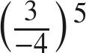
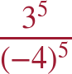
Keep the parentheses on the negative base.

The zero exponent.
7. Fill in the missing value in the pattern: 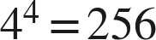, 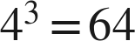, 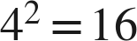, 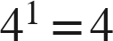, 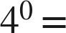 ____
1
Each value is the previous one divided by 4; 4 ÷ 4 = 1.

8. Evaluate  and explain in one sentence why your answer is not 0.
1 — the exponent counts factors of 9; with none multiplied in, what is left is 1 (or: 9³/9³ = 1 and 9³/9³ = 9⁰).

For questions 9 through 11, rewrite the expression using a law of exponents, name the law, then evaluate.
9. 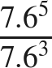
 — quotient of powers

10. 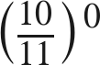
1 — zero exponent

11. 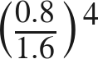
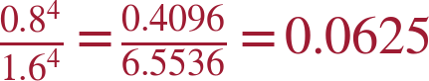 — power of a quotient (or 0.5⁴ = 0.0625)

Working backwards.
12. Find the value of that makes each statement true.
a. 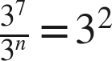
n = 5
7 − n = 2.
b. 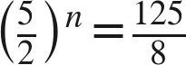
n = 3
5³ = 125 and 2³ = 8.
c. 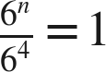
n = 4
The quotient is 6⁰ only when the exponents match.

13. Which expression is equivalent to 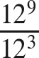 ?
○ A. 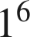
● B. 
○ C. 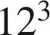
○ D. 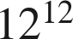
B
Same base, subtract.

14. Select ALL of the expressions whose value is 1.
☐ A. 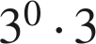
☒ B. 
☒ C. 
☒ D. 
☒ E. 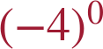
☐ F. 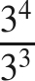
B, C, D and E

